PHASE 1: Brainstorming & Ideation Phase
Project Team Members
M.G Misriyathul Ibrahima
S.M.B.N Meera Jenira
V.Mohana
P.Mutharasi
S.A.K. Muthu Ameena

Project: Implement Client Script & UI Policy (Incident)
ServiceNow – Incident Management

Phase Objective
To identify the Incident data-entry and consistency problems that could be addressed using ServiceNow UI Policies and Client Scripts.

Problem Identification
Incident records require accurate and consistent information for triage, assignment, prioritization, and resolution. Manual checking can allow incomplete or inconsistent values to be submitted.

Idea Generation
The proposed solution was to apply client-side controls directly on the Incident form. The main idea was to use a UI Policy for conditional field behavior and Client Scripts for automatic value setting, save-time validation, and list-edit restriction.

Proposed Solution
- Create a UI Policy named High Impact Control.
- Use Impact = 1 – High as the main condition.
- Make Assigned To mandatory for High Impact incidents.
- Make Urgency read-only when Impact is High.
- Automatically set Urgency to High when Impact changes to High.
- Prevent saving a High Impact incident when Assigned To is empty.
- Prevent direct State changes through list editing while allowing form-based State updates.

Initial Workflow
Incident → Check Impact → Apply UI Policy/Client Script → Validate required information → Allow or prevent the requested action.

Project Evidence – Screenshots
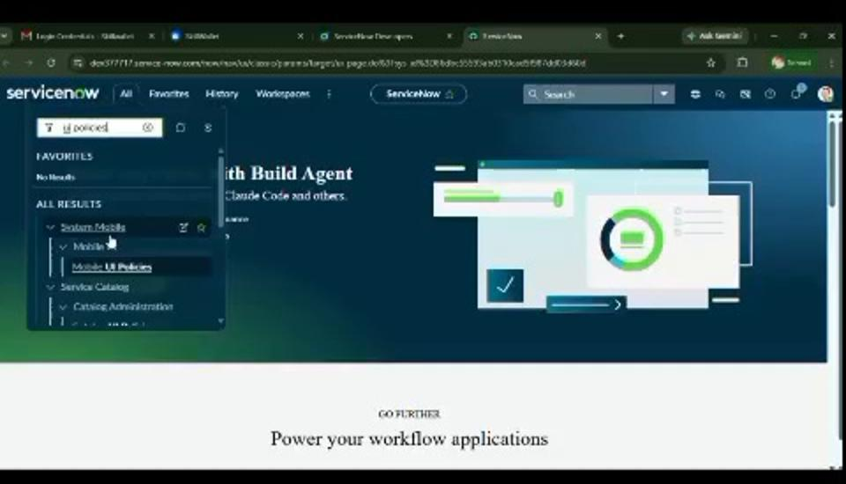
Figure 1. ServiceNow environment used for the project.

Phase Outcome
The project idea was defined around improving Incident data quality and controlling user interaction through ServiceNow client-side configuration.

